ETHICAL HACKING LAB

EXPERIMENT 1
Aim: To execute and display the results for the following commands in Kali Linux Operating Systems: rm, users and tree.
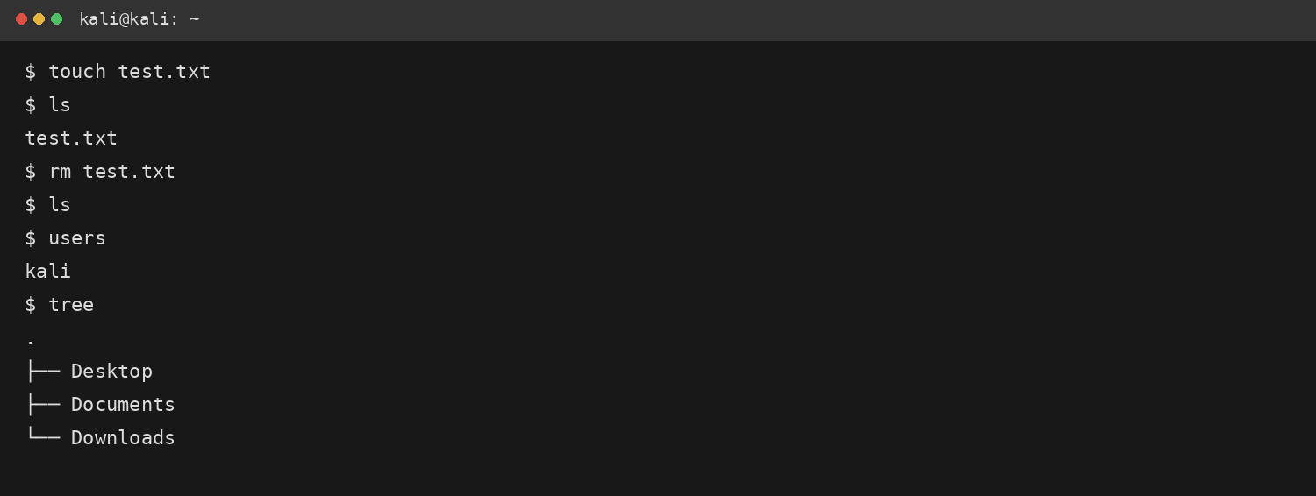

EXPERIMENT 2
Aim: To execute and display the results for the following commands in Kali Linux Operating Systems: less, more and vi.
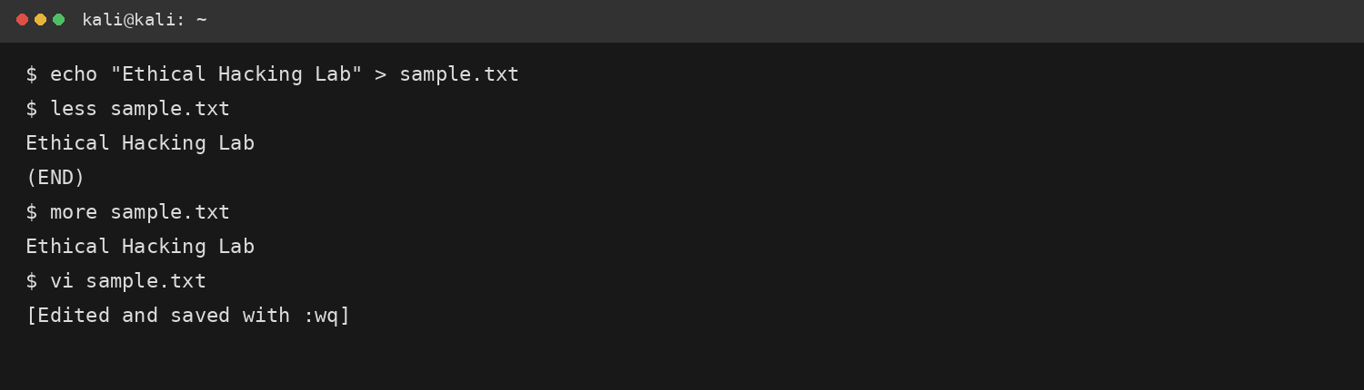

EXPERIMENT 3
Aim: To execute and display the results for the following commands in Kali Linux Operating Systems: tree, head and tail.
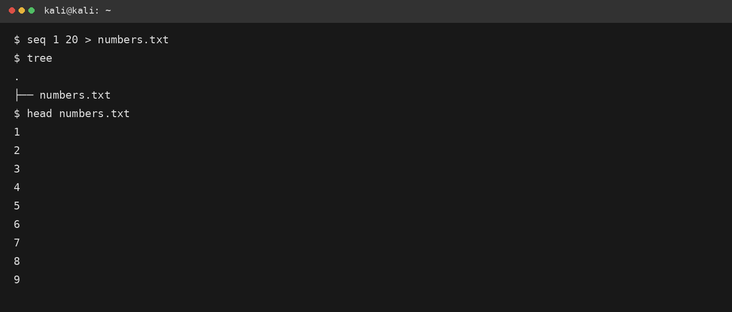
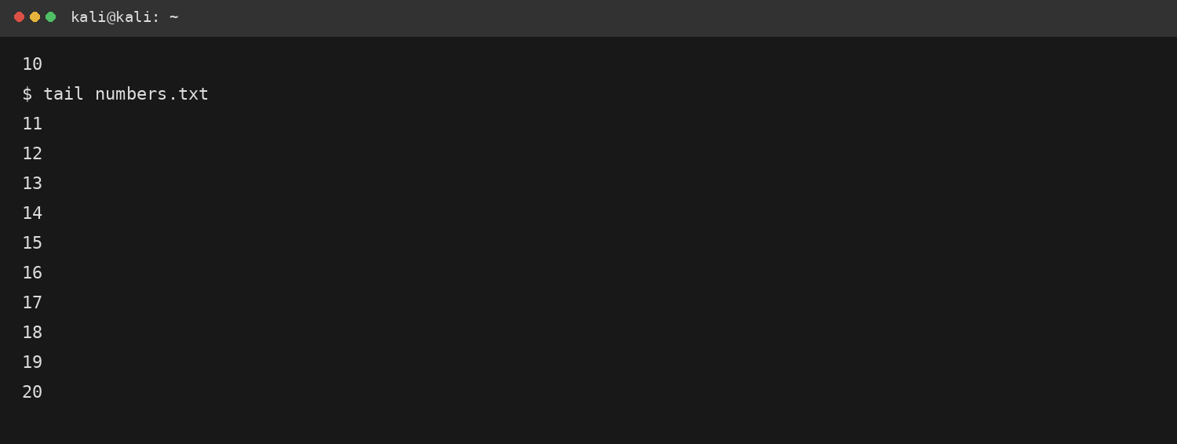

EXPERIMENT 4
Aim: To execute and display the results for the following commands in Kali Linux Operating Systems: ls, cat and mkdir.
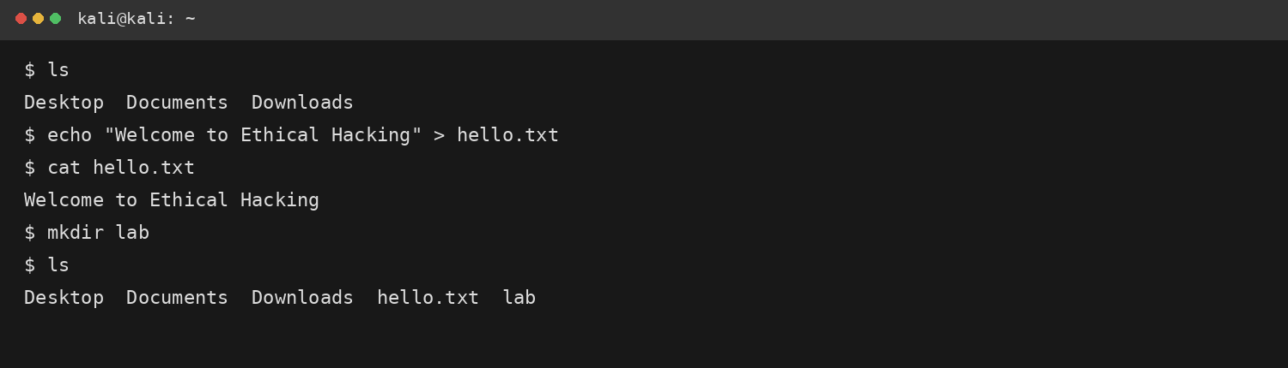

EXPERIMENT 5
Aim: To execute and display the results for the following commands in Kali Linux Operating Systems: uptime, date and mv.
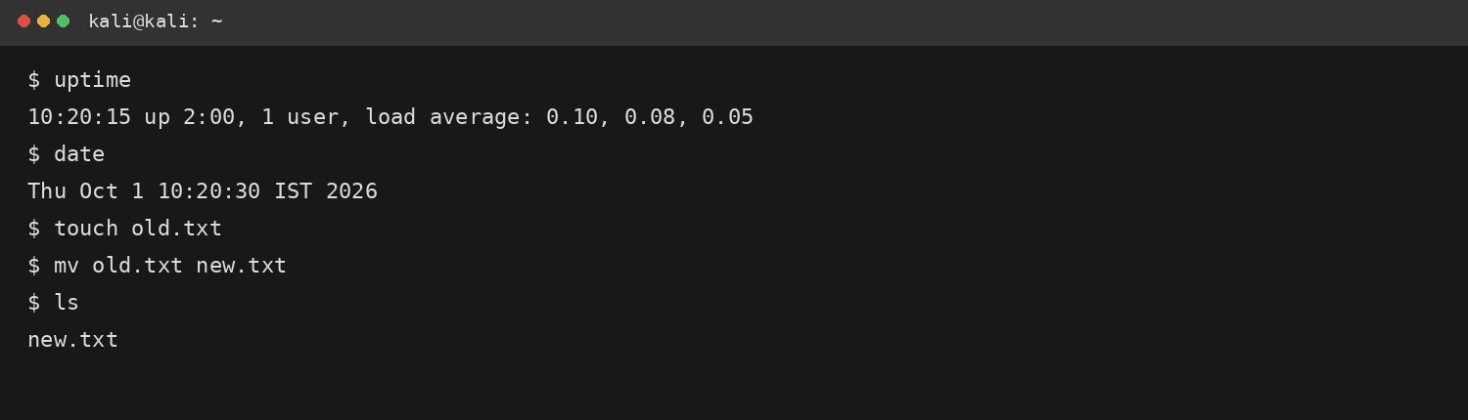

EXPERIMENT 6
Aim: To execute and display the results for the following commands in Kali Linux Operating Systems: touch, pwd and wget.
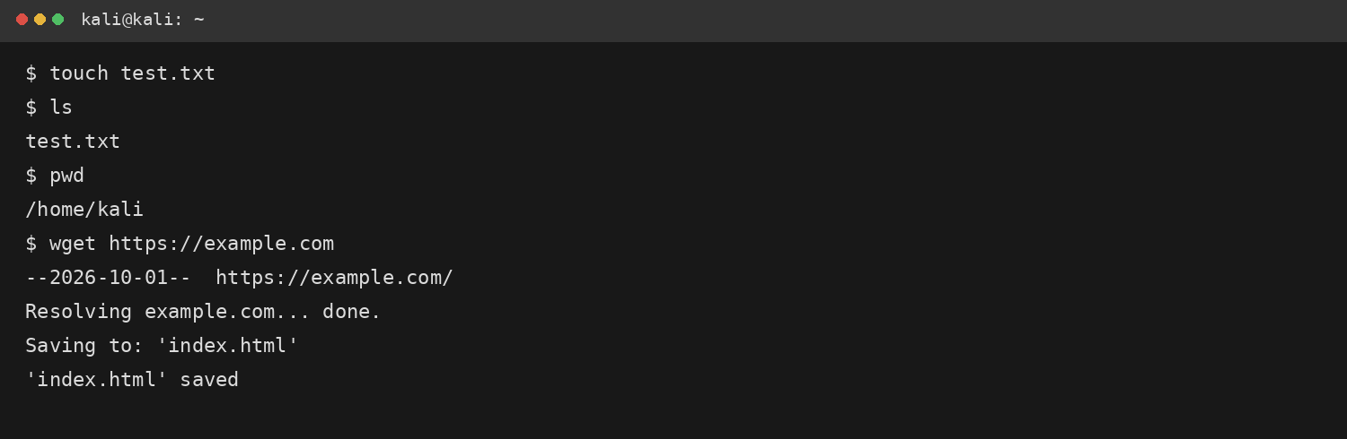

EXPERIMENT 7
Aim: To execute and display the results for the following commands in Kali Linux Operating Systems: cd, cp and ls.
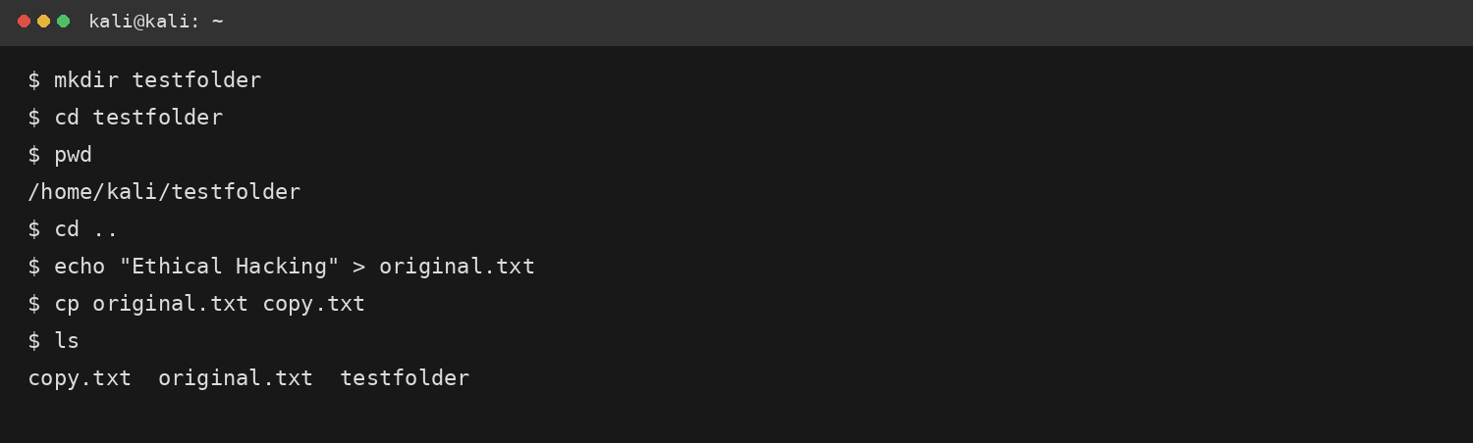

EXPERIMENT 8
Aim: To execute and display the results for the following Nmap service version and OS detection commands in Kali Linux operating systems.
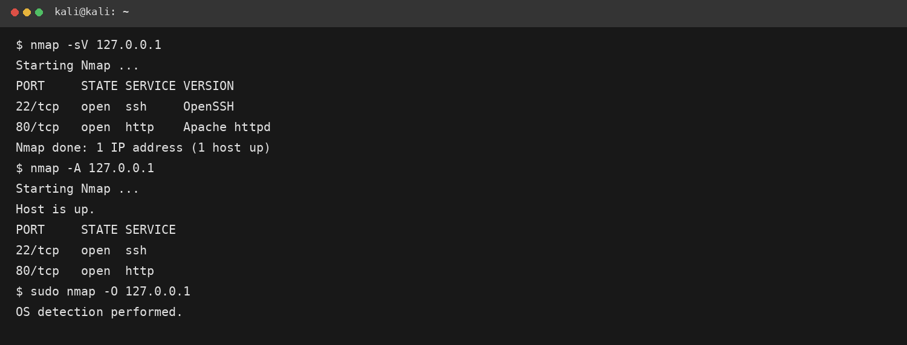

EXPERIMENT 9
Aim: To execute and display the results for the following Nmap Timing and performance commands in Kali Linux operating systems: polite IDS evasion and normal IDS evasion.
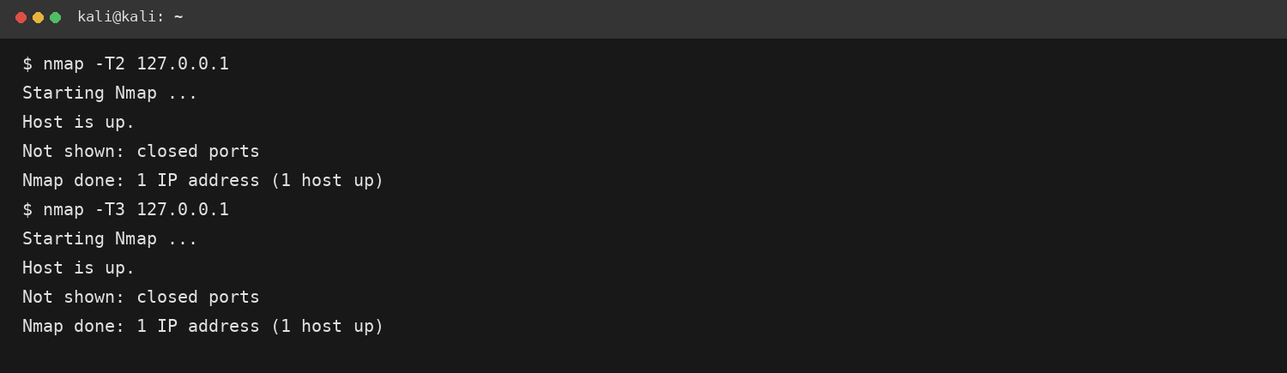

EXPERIMENT 10
Aim: To execute the following commands in Kali Linux Operating Systems: Free command, Sort command and History command.
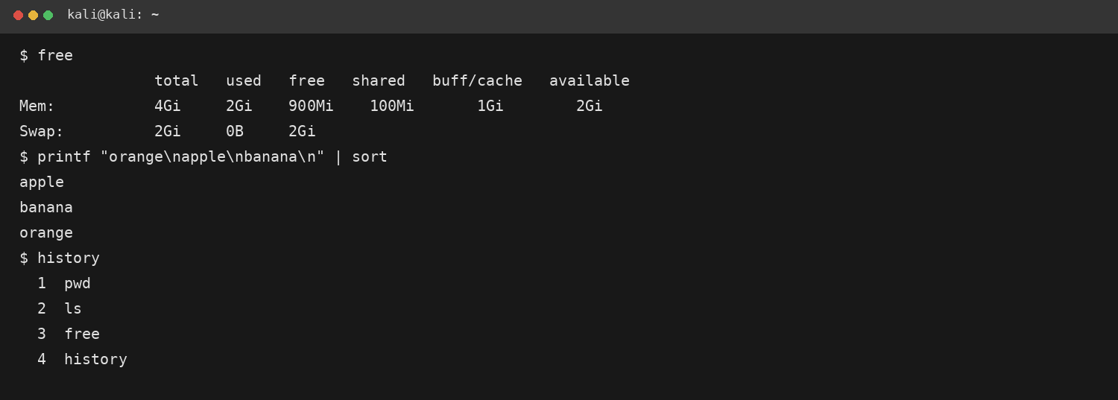

EXPERIMENT 11
Aim: To execute and display the results for the following Nmap Timing and performance commands in Kali Linux operating systems: aggressive speed scan and insane speed scan.
